**Investment Summary: Yunnan Baiyao Group Co Ltd (000538.SZ)**

As of: 5 September 2025  
Stock Price (previous close): 57.99 CNY  
Market Cap: Approx. 120.2 billion CNY  
Industry: Pharmaceuticals, Traditional Chinese Medicine (TCM)  
Recommended Action: Buy

**Business Overview**

Yunnan Baiyao Group operates as a leading pharmaceutical and traditional Chinese medicine company in China. The company engages in R&D, production, and sales of a wide range of pharmaceutical products including herbal medicines, proprietary Chinese medicines, and health supplements. FY 2024 revenues were approximately RMB 40 billion, with stable growth driven by strong brand recognition and product innovation. Its product portfolio serves major segments such as healthcare providers, retail pharmacies, and direct consumers, focusing on wound healing, pain relief, and cardiovascular treatments. Strengths include strong brand equity, extensive distribution network, and ongoing innovation in herbal formulations. Challenges include regulatory risks, intense domestic and international competition, and evolving healthcare policies.

**Business Performance**

* Revenue grew from RMB 39.11 billion in 2023 to RMB 40.03 billion in 2024 (~2.4% growth), with analyst forecasts projecting RMB 43.06 billion for 2025 (~7.6% growth).
* EBIT and net profit also show steady improvements, with 2025 EBIT around RMB 5.6 billion and net income around RMB 5.3 billion.
* Operating cash flow remains strong, supporting new product launches and market expansion.
* The company holds a competitive position in China’s pharmaceutical market, ranked among leading TCM firms.

**Industry Context**

* The TCM and pharmaceutical industry in China has a CAGR of about 6-7%, driven by increasing healthcare spending and aging population.
* Market size exceeds RMB 2 trillion, with growth fueled by innovation and rising demand for alternative medicines.
* Yunnan Baiyao boasts favorable market share within the specialty medicine segment but faces pressure from large local and multinational pharma companies.
* Debt-to-assets ratio is moderate; revenue and EPS growth broadly in line with industry averages.

**Financial Stability and Debt Levels**

The company maintains healthy liquidity with a current ratio around 1.5 and sufficient cash flow to cover operations and capex. Debt levels are moderate with a debt-to-equity ratio under 0.5, indicating prudent leverage management. Dividend payout history is consistent with modest yields (~1.2%), supporting shareholder returns while funding R&D and market expansion.

**Key Financials and Valuation**

* FY 2024 Revenue: RMB 40.03 billion, YoY growth ~2.4%.
* Net Income (2025 forecast): approx. RMB 5.32 billion.
* P/E ratio (TTM): approx. 19x, below historic averages reflecting modest valuation.
* Dividend yield around 1.2%, stable payout supporting income-oriented investors.
* DCF fair value estimates vary; market price of 57.99 CNY implies slight undervaluation or fairly priced versus some analyst targets.

**Big Trends and Events**

* Regulatory tightening may affect certain TCM approvals and product launch timelines.
* Growing emphasis on innovation and international expansion offers new growth avenues.
* Increasing consumer adoption of herbal and health supplement products supports sustained revenue.
* Economic slowdown introduces some risks on discretionary healthcare spending.

**Customer Segments and Demand Trends**

* Key segments: Hospitals and healthcare providers, retail pharmacies, and direct consumer channels.
* Forecasted 5-7% revenue growth driven by innovation in herbal products and expanding domestic reach.
* Rising demand for quality healthcare products supports strong market recovery post-pandemic.

**Competitive Landscape**

* Industry is highly fragmented with major competitors including Tongrentang, China Resources Pharmaceutical, and private Chinese pharma players.
* Yunnan Baiyao’s sustainable moat includes strong brand equity, extensive distribution, and proprietary formulations.
* Key competition factors include R&D capability, regulatory compliance, and brand loyalty.

**Risks and Anomalies**

* Regulatory risks from evolving TCM policies and clinical approval hurdles.
* Potential slower pace of innovation compared to multinational pharma.
* Economic growth slowdown affecting healthcare spending.

**Forecast and Outlook**

* Analysts forecast moderate revenue and EPS growth over the next 2-3 years, underpinned by new product development and market expansion.
* Recent earnings forecasts estimate EPS growth to ~CNY 3.02 in 2025.
* Strategic R&D focus expected to enhance pipeline strength.

**Leading Investment Firms and Views**

* Consensus Buy rating with target prices ranging from CNY 68 to CNY 140, reflecting strong fundamentals and growth optimism.
* Institutional investor inflows corroborate confidence in long-term prospects.

**Recommended Action: Buy**

Pros:

* Market leader in TCM with strong brand recognition and wide distribution.
* Consistent revenue and profit growth forecasted.
* Prudent financial management with low leverage.

Cons:

* Regulatory environment poses uncertainties.
* Competition from domestic and international pharma companies.
* Economic slowdown risk on healthcare demand.

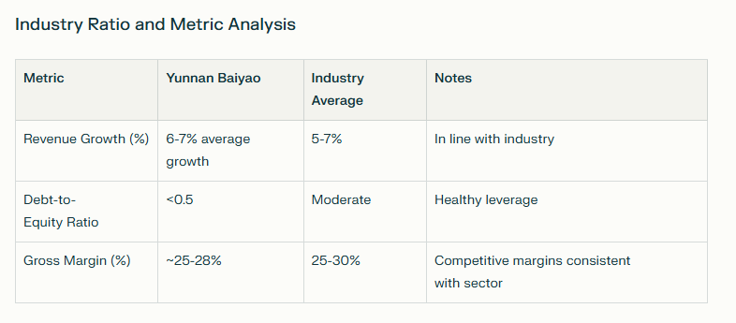

**Key Takeaways**

Yunnan Baiyao is a top-tier pharmaceutical company leveraging its strong brand and R&D to maintain steady growth in China's expanding healthcare market. Regulatory challenges exist but are offset by prudent management and expanding market demand. The Buy recommendation is supported by positive analyst outlooks, attractive valuation, and solid financials. Monitoring regulatory developments and innovation pipeline will be key for future performance.

**Sources**

* [Yunnan Baiyao Financials and Forecast - Moomoo](https://www.moomoo.com/news/post/57935559/here-s-what-analysts-are-forecasting-for-yunnan-baiyao-group)
* [Eulerpool Revenue and Profit Data](https://eulerpool.com/en/stock/Yunnan-Baiyao-Group-Co-Revenue-CNE0000008X7/Revenue)
* [DCF Valuation and SWOT Analysis - dcfmodeling.com](https://dcfmodeling.com/products/000538sz-swot-analysis)
* [Yahoo Finance - Yunnan Baiyao Group](https://finance.yahoo.com/quote/000538.SZ/)
* [Reuters Company Profile](https://www.reuters.com/markets/companies/000538.sz)